Case Study for State Transition Technique-
Find out minimum 5 images from browser and identify state transition techniques.
1.Switch ON/OFF System


States: Initial State → OFF → ON → Final State
- Valid Transition: Switch On → OFF → ON
- Valid Transition: Switch Off → ON → OFF
- Final Transition: Shut Down → ON → Final State
2. Local Cancer Cell State Transition
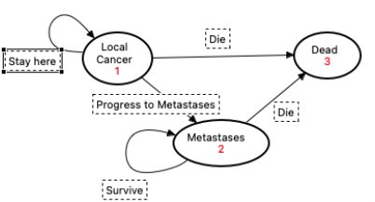
States: Local Cancer Cell → Metastases → Dead
- Valid Transition: Progress to Metastases → Local Cancer Cell → Metastases
- Valid Transition: Survive → Metastases → Metastases
- Final Transition: Die → Local Cancer Cell / Metastases → Dead

3. Aircraft Landing Gear State Transition

States: Waiting for Take Off → Waiting for Timer → Raising Gear → Gear Up → Lowering Gear → Gear Down
- Valid Transition: PlaneOnGround → Waiting for Take Off → Waiting for Timer
- Valid Transition: TimeUp & PilotLever → Waiting for Timer → Raising Gear → Gear Up
- Valid Transition: PilotLever → Gear Up → Lowering Gear → Gear Down
- Final Transition: PlaneOnGround → Gear Down → Waiting for Take Off

4. ATM PIN Authentication
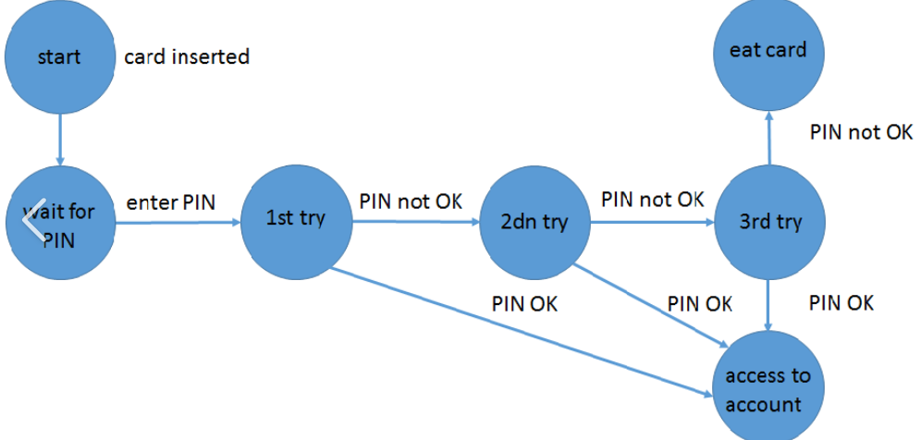
States: Start → Wait for PIN → 1st Try → 2nd Try → 3rd Try → Access to Account / Eat Card
- Valid Transition: PIN OK → 1st Try / 2nd Try / 3rd Try → Access to Account
- Invalid Transition: PIN not OK → 1st Try → 2nd Try → 3rd Try
- Final Transition: PIN not OK at 3rd Try → Eat Card

5. Marital Status State Transition
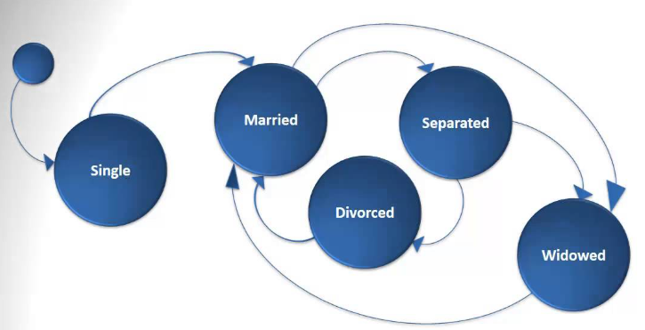
States: Initial State → Single → Married → Separated → Divorced → Widowed
- Valid Transition: Marriage → Single → Married
- Valid Transition: Separation → Married → Separated
- Valid Transition: Divorce → Separated → Divorced
- Final Transition: Death of spouse → Married / Separated → Widowed

